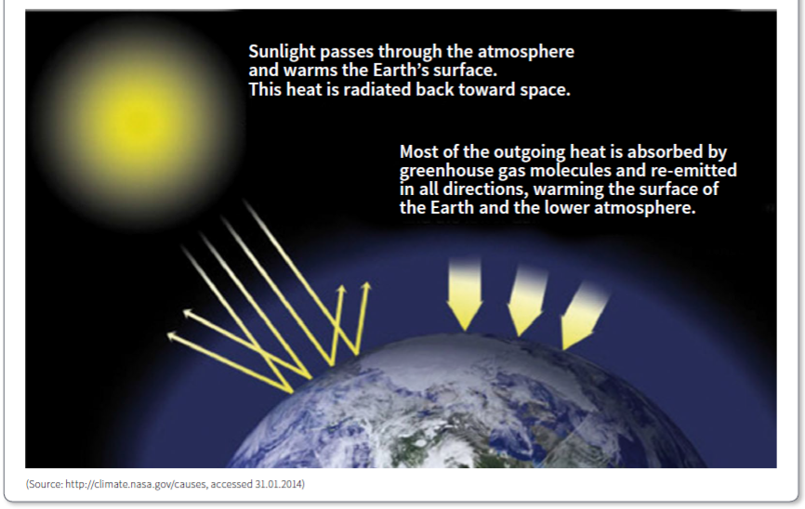
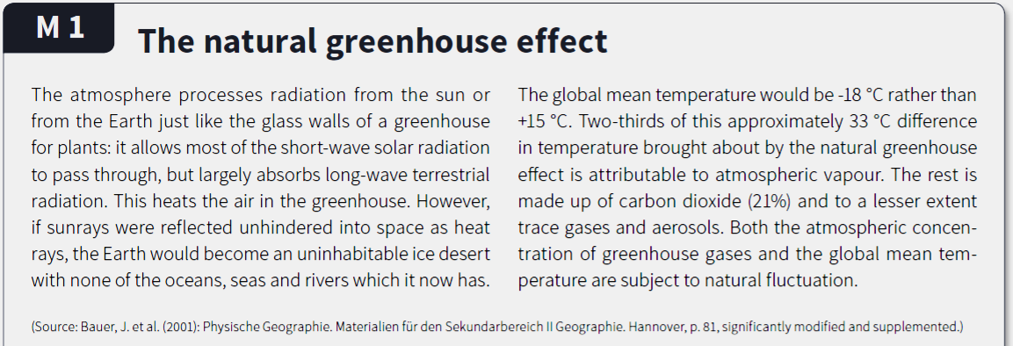

Questions
  - The natural greenhouse effect above is described using three sentences on the diagram. Summarise this information in one sentence which accurately describes the natural greenhouse effect.
____________________________________________________________________________________________________________________________________________________________
  - If the greenhouse gases did not exist what would the climate on earth be like?
____________________________________________________________________________________________________________________________________________________________
  - If water vapour causes most of the global warming why are we so worried about CO₂ gas?
____________________________________________________________________________________________________________________________________________________________

